Learning Outcome
In this section, we will read about:
- Machine learning and its types & applications
- Supervised machine learning techniques
- Classification vs regression
- Understanding Regression and types
- Linear regression using OLS
- Multi-Variate Linear Regression
- Correlation concepts
- Metrics- Loss function, MSE, RMSE, MAE, R2 Score

Machine Learning
Machine Learning is the field of study that gives computers the capability to learn without being explicitly programmed. ML is one of the most exciting technologies that one would have ever come across. As it is evident from the name, it gives the computer that makes it more similar to humans: The ability to learn.
Machine learning is a growing technology which enables computers to learn automatically from past data. Machine learning uses various algorithms for building mathematical models and making predictions using historical data or information. Currently, it is being used for various tasks such as image recognition, speech recognition, email filtering, Facebook auto-tagging, recommender system, and many more.

How does Machine Learning Work?
A Machine Learning system learns from historical data, builds the prediction models, and whenever it receives new data, predicts the output for it. The accuracy of predicted output depends upon the amount of data, as the huge amount of data helps to build a better model which predicts the output more accurately.
Suppose we have a complex problem, where we need to perform some predictions, so instead of writing a code for it, we just need to feed the data to generic algorithms, and with the help of these algorithms, machine builds the logic as per the data and predict the output. Machine learning has changed our way of thinking about the problem. The below block diagram explains the working of Machine Learning algorithm:
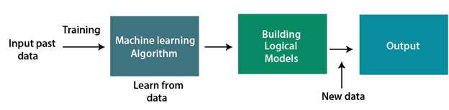
Image 1- Machine Learning
Reference: https://static.javatpoint.com/tutorial/machine-learning/images/introduction-to-machine-learning2.png

Applications of Machine learning

Machine learning is a buzzword for today's technology, and it is growing very rapidly day by day. We are using machine learning in our daily life even without knowing it such as Google Maps, Google assistant, Alexa, etc. Below are some most trending real-world applications of machine learning:

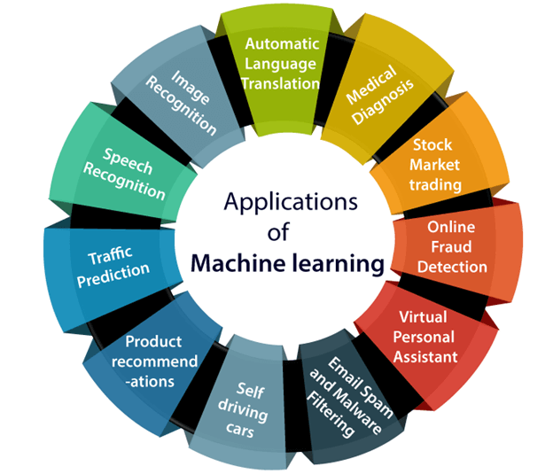
Image 2- Machine Learning Application
Reference: https://static.javatpoint.com/tutorial/machine-learning/images/applications-of-machine-learning.png

Image Recognition:
Image recognition is one of the most common applications of machine learning. It is used to identify objects, persons, places, digital images, etc. The popular use case of image recognition and face detection is, Automatic friend tagging suggestion:
Facebook provides us a feature of auto friend tagging suggestion. Whenever we upload a photo with our Facebook friends, then we automatically get a tagging suggestion with name, and the technology behind this is machine learning's face detection and recognition algorithm. It is based on the Facebook project named "Deep Face," which is responsible for face recognition and person identification in the picture.

Speech Recognition:
While using Google, we get an option of "Search by voice," it comes under speech recognition, and it's a popular application of machine learning.
Speech recognition is a process of converting voice instructions into text, and it is also known as "Speech to text", or "Computer speech recognition." At present, machine learning algorithms are widely used by various applications of speech recognition. Google assistant, Siri, Cortana, and Alexa are using speech recognition technology to follow the voice instructions.

Traffic prediction:
If we want to visit a new place, we take help of Google Maps, which shows us the correct path with the shortest route and predicts the traffic conditions. It predicts the traffic conditions such as whether traffic is cleared, slow-moving, or heavily congested with the help of two ways:
Real Time location of the vehicle form Google Map app and sensors
Average time has taken on past days at the same time.
Everyone who is using Google Map is helping this app to make it better. It takes information from the user and sends back to its database to improve the performance.

Product recommendations:
Machine learning is widely used by various e-commerce and entertainment companies such as Amazon, Netflix, etc., for product recommendation to the user. Whenever we search for some product on Amazon, then we started getting an advertisement for the same product while internet surfing on the same browser and this is because of machine learning. Google understands the user interest using various machine learning algorithms and suggests the product as per customer interest.
As similar, when we use Netflix, we find some recommendations for entertainment series, movies, etc., and this is also done with the help of machine learning.

Self-driving cars:
One of the most exciting applications of machine learning is self-driving cars. Machine learning plays a significant role in self-driving cars. Tesla, the most popular car manufacturing company is working on self-driving car. It is using unsupervised learning method to train the car models to detect people and objects while driving.

Email Spam and Malware Filtering:
Whenever we receive a new email, it is filtered automatically as important, normal, and spam. We always receive an important mail in our inbox with the important symbol and spam emails in our spam box, and the technology behind this is Machine learning. Below are some spam filters used by Gmail:
- Content Filter
- Header filter
- General blacklists filter
- Rules-based filters
- Permission filters
Some machine learning algorithms such as Multi-Layer Perceptron, Decision tree, and Naïve Bayes classifier are used for email spam filtering and malware detection.

Virtual Personal Assistant:
We have various virtual personal assistants such as Google assistant, Alexa, Cortana, Siri. As the name suggests, they help us in finding the information using our voice instruction. These assistants can help us in various ways just by our voice instructions such as Play music, call someone, Open an email, Scheduling an appointment, etc. These virtual assistants use machine learning algorithms as an important part. These assistant record our voice instructions, send it over the server on a cloud, and decode it using ML algorithms and act accordingly.
- Online Fraud Detection:
Machine learning is making our online transaction safe and secure by detecting fraud transaction. Whenever we perform some online transaction, there may be various ways that a fraudulent transaction can take place such as fake accounts, fake ids, and steal money in the middle of a transaction. So to detect this, Feed Forward Neural network helps us by checking whether it is a genuine transaction or a fraud transaction.
For each genuine transaction, the output is converted into some hash values, and these values become the input for the next round. For each genuine transaction, there is a specific pattern which gets change for the fraud transaction hence, it detects it and makes our online transactions more secure.
- Stock Market trading:
Machine learning is widely used in stock market trading. In the stock market, there is always a risk of up and downs in shares, so for this machine learning's long short term memory neural network is used for the prediction of stock market trends.
- Medical Diagnosis:
In medical science, machine learning is used for diseases diagnoses. With this, medical technology is growing very fast and able to build 3D models that can predict the exact position of lesions in the brain. It helps in finding brain tumors and other brain-related diseases easily.
- Automatic Language Translation:
Nowadays, if we visit a new place and we are not aware of the language then it is not a problem at all, as for this also machine learning helps us by converting the text into our known languages. Google's GNMT (Google Neural Machine Translation) provide this feature, which is a Neural Machine Learning that translates the text into our familiar language, and it called as automatic translation.
The technology behind the automatic translation is a sequence-to-sequence learning algorithm, which is used with image recognition and translates the text from one language to another language.

Types of Machine Learning
There are different ways to train machine learning algorithms, each with their own advantages and disadvantages. To understand the pros and cons of each type of machine learning, we must first look at what kind of data they ingest. In ML, there are two kinds of data — labeled data and unlabeled data.
Labeled data has both the input and output parameters in a completely machine-readable pattern, but requires a lot of human labor to label the data, to begin with. Unlabeled data only has one or none of the parameters in a machine-readable form. This negates the need for human labor but requires more complex solutions.
There are also some types of machine learning algorithms that are used in very specific use-cases, but three main methods are used today.
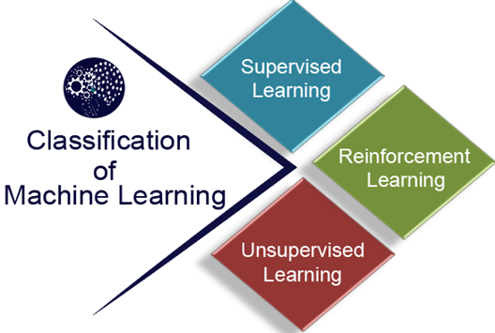
Image 3- Machine Learning Types
Reference: https://static.javatpoint.com/tutorial/machine-learning/images/classification-of-machine-learning.png
- Supervised Learning:
Supervised learning is when the model is getting trained on a labelled dataset. A labelled dataset is one that has both input and output parameters. In this type of learning both training and validation, datasets are labelled as shown in the figures below.

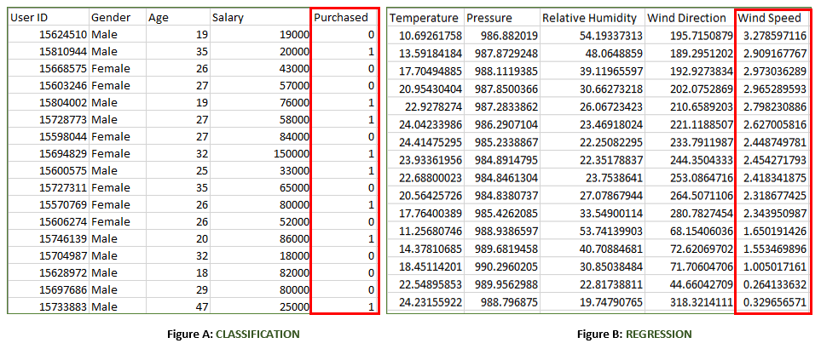

Image 4- Supervised Learning Approach
Reference: https://media.geeksforgeeks.org/wp-content/uploads/supervised-data.png

Figure A: It is a dataset of a shopping store that is useful in predicting whether a customer will purchase a particular product under consideration or not based on his/ her gender, age, and salary.
Input: Gender, Age and Salary
Output: Purchased i.e., 0 or 1; 1 means yes the customer will purchase and 0 means that the customer won’t purchase it.

Figure B: It is a Meteorological dataset that serves the purpose of predicting wind speed based on different parameters.
Input: Dew Point, Temperature, Pressure, Relative Humidity, Wind Direction
Output: Wind Speed

Unsupervised Learning
Unsupervised learning is a learning method in which a machine learns without any supervision. The training is provided to the machine with the set of data that has not been labeled, classified, or categorized, and the algorithm needs to act on that data without any supervision. The goal of unsupervised learning is to restructure the input data into new features or a group of objects with similar patterns. In unsupervised learning, we don't have a predetermined result. The machine tries to find useful insights from the huge amount of data. It can be further classifieds into two categories of algorithms:

- Clustering
- Association

Reinforcement Learning
Reinforcement learning is a feedback-based learning method, in which a learning agent gets a reward for each right action and gets a penalty for each wrong action. The agent learns automatically with these feedbacks and improves its performance. In reinforcement learning, the agent interacts with the environment and explores it. The goal of an agent is to get the most reward points, and hence, it improves its performance.
The robotic dog, which automatically learns the movement of his arms, is an example of Reinforcement learning.

Types of Supervised Learning:

- Classification: It is a Supervised Learning task where output is having defined labels (discrete value). For example, in above Figure A, Output – Purchased has defined labels i.e., 0 or 1; 1 means the customer will purchase and 0 means that customer won’t purchase. The goal here is to predict discrete values belonging to a particular class and evaluate them on the basis of accuracy. It can be either binary or multi-class classification. In binary classification, the model predicts either 0 or 1; yes or no but in the case of multi-class classification, the model predicts more than one class.
Example: Gmail classifies mails in more than one class like social, promotions, updates, forums.
Classification is a process of finding a function which helps in dividing the dataset into classes based on different parameters. In Classification, a computer program is trained on the training dataset and based on that training, it categorizes the data into different classes. The task of the classification algorithm is to find the mapping function to map the input(x) to the discrete output(y).

Example: The best example to understand the Classification problem is Email Spam Detection. The model is trained on the basis of millions of emails on different parameters, and whenever it receives a new email, it identifies whether the email is spam or not. If the email is spam, then it is moved to the Spam folder.

Classification Algorithms can be further divided into the following types:
- Logistic Regression
- K-Nearest Neighbours
- Support Vector Machines
- Kernel SVM
- Naïve Bayes
- Decision Tree Classification
- Random Forest Classification

- Regression: It is a Supervised Learning task where output is having continuous value. Example in above Figure B, Output – Wind Speed is not having any discrete value but is continuous in the particular range. The goal here is to predict a value as much closer to the actual output value as our model can and then evaluation is done by calculating the error value. The smaller the error the greater the accuracy of our regression model.
Regression is a process of finding the correlations between dependent and independent variables. It helps in predicting the continuous variables such as prediction of Market Trends, prediction of House prices, etc. The task of the Regression algorithm is to find the mapping function to map the input variable(x) to the continuous output variable(y).
Example: Suppose we want to do weather forecasting, so for this, we will use the Regression algorithm. In weather prediction, the model is trained on the past data, and once the training is completed, it can easily predict the weather for future days.

Regression vs. Classification in Machine Learning
Regression and Classification algorithms are Supervised Learning algorithms. Both the algorithms are used for prediction in Machine learning and work with the labeled datasets. But the difference between both is how they are used for different machine learning problems.
The main difference between Regression and Classification algorithms that Regression algorithms are used to predict the continuous values such as price, salary, age, etc. and Classification algorithms are used to predict/Classify the discrete values such as Male or Female, True or False, Spam or Not Spam, etc.
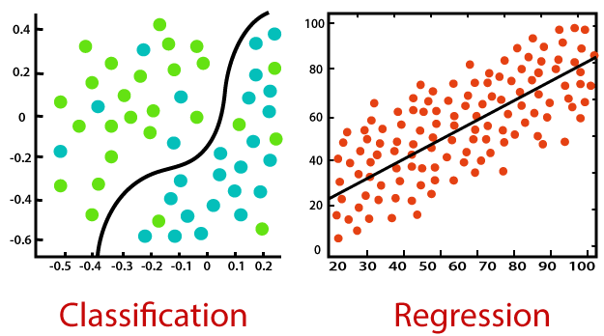

Image 5- Regression vs. Classification
Reference: https://static.javatpoint.com/tutorial/machine-learning/images/regression-vs-classification-in-machine-learning.png

Regression Algorithm | Classification Algorithm
In Regression, the output variable must be of continuous nature or real value. | In Classification, the output variable must be a discrete value.
The task of the regression algorithm is to map the input value (x) with the continuous output variable(y). | The task of the classification algorithm is to map the input value(x) with the discrete output variable(y).
Regression Algorithms are used with continuous data. | Classification Algorithms are used with discrete data.
In Regression, we try to find the best fit line, which can predict the output more accurately. | In Classification, we try to find the decision boundary, which can divide the dataset into different classes.
Regression algorithms can be used to solve the regression problems such as Weather Prediction, House price prediction, etc. | Classification Algorithms can be used to solve classification problems such as Identification of spam emails, Speech Recognition, Identification of cancer cells, etc.
The regression Algorithm can be further divided into Linear and Non-linear Regression. | The Classification algorithms can be divided into Binary Classifier and Multi-class Classifier.

Understanding Regression and types
Regression analysis is a statistical method to model the relationship between a dependent (target) and independent (predictor) variables with one or more independent variables. More specifically, Regression analysis helps us to understand how the value of the dependent variable is changing corresponding to an independent variable when other independent variables are held fixed. It predicts continuous/real values such as temperature, age, salary, price, etc.
Example: Suppose there is a marketing company A, who does various advertisement every year and get sales on that. The below list shows the advertisement made by the company in the last 5 years and the corresponding sales:
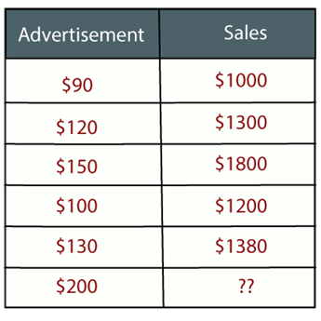

Image 6- Regression Analysis
Reference: https://static.javatpoint.com/tutorial/machine-learning/images/regression-analysis-in-machine-learning.png

Now, the company wants to do the advertisement of $200 in the year 2019 and wants to know the prediction about the sales for this year. So to solve such type of prediction problems in machine learning, we need regression analysis.
Regression is a supervised learning technique which helps in finding the correlation between variables and enables us to predict the continuous output variable based on the one or more predictor variables. It is mainly used for prediction, forecasting, time series modeling, and determining the causal-effect relationship between variables.
In Regression, we plot a graph between the variables which best fits the given data points, using this plot, the machine learning model can make predictions about the data. In simple words, "Regression shows a line or curve that passes through all the datapoints on target-predictor graph in such a way that the vertical distance between the data points and the regression line is minimum." The distance between data points and line tells whether a model has captured a strong relationship or not.
Regression analysis helps in the prediction of a continuous variable. There are various scenarios in the real world where we need some future predictions such as weather condition, sales prediction, marketing trends, etc., for such case we need some technology which can make predictions more accurately. So, for such case we need Regression analysis which is a statistical method and used in machine learning and data science. Below are some other reasons for using Regression analysis:
- Regression estimates the relationship between the target and the independent variable.
- It is used to find the trends in data.
- It helps to predict real/continuous values.
- By performing the regression, we can confidently determine the most important factor, the least important factor, and how each factor is affecting the other factors.

Types of Regression
There are various types of regressions which are used in data science and machine learning. Each type has its own importance on different scenarios, but at the core, all the regression methods analyze the effect of the independent variable on dependent variables. Here we are discussing some important types of regression which are given below:
- Linear Regression
- Logistic Regression
- Polynomial Regression
- Support Vector Regression
- Decision Tree Regression
- Random Forest Regression
- Ridge Regression
- Lasso Regression:

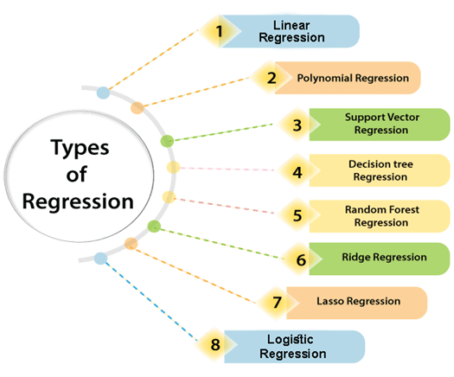

Image 7- Types of Regression
Reference: https://static.javatpoint.com/tutorial/machine-learning/images/types-of-regression.png

Linear Regression:
- Linear regression is a statistical regression method which is used for predictive analysis.
- It is one of the very simple and easy algorithms which works on regression and shows the relationship between the continuous variables.
- It is used for solving the regression problem in machine learning.
- Linear regression shows the linear relationship between the independent variable (X-axis) and the dependent variable (Y-axis), hence called linear regression.
- If there is only one input variable (x), then such linear regression is called simple linear regression. And if there is more than one input variable, then such linear regression is called multiple linear regression.
- The relationship between variables in the linear regression model can be explained using the below image. Here we are predicting the salary of an employee on the basis of the year of experience.
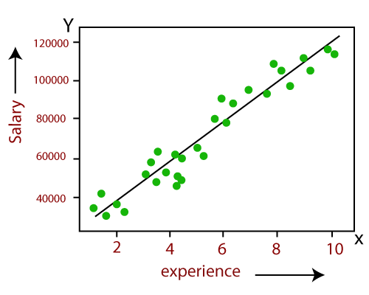

Image 8- Dependent (Salary) and Independent (Experience) Variable
Reference: https://static.javatpoint.com/tutorial/machine-learning/images/types-of-regression2.png

The mathematical equation for Linear regression:
Y= aX+b
Here, Y = dependent variables (target variables), X= Independent variables (predictor variables), a and b are the linear coefficients

Linear regression using Ordinary Least Squares (OLS)
Ordinary least squares, or linear least squares, estimates the parameters in a regression model by minimizing the sum of the squared residuals. This method draws a line through the data points that minimizes the sum of the squared differences between the observed values and the corresponding fitted values.

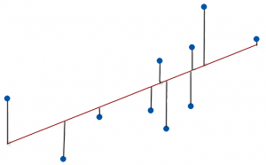

Image 9- Ordinary least squares line
Reference: https://statisticsbyjim.com/glossary/ordinary-least-squares/#:~:text=Ordinary%20least%20squares%2C%20or%20linear,and%20the%20corresponding%20fitted%20values
- The Ordinary Least Squares procedure seeks to minimize the sum of the squared residuals. This means that given a regression line through the data we calculate the distance from each data point to the regression line, square it, and sum all of the squared errors together. This is the quantity that ordinary least squares seeks to minimize.
- This approach treats the data as a matrix and uses linear algebra operations to estimate the optimal values for the coefficients. It means that all of the data must be available and you must have enough memory to fit the data and perform matrix operations.
- Ordinary Least Squares is a form of statistical regression used as a way to predict unknown values from an existing set of data. An example of a scenario in which one may use Ordinary Least Squares, or OLS, is in predicting shoe size from a data set that includes height and shoe size. Given the data, one can use the ordinary least squares formula to create a rate of change and predict shoe size, given a subject's height. In short, OLS takes an input, the independent variable, and produces an output, the dependent variable.
OLS method equation:
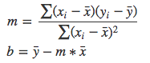
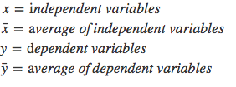
Ordinary Least Squares method works for both univariate dataset which means single independent variables and single dependent variables and multi-variate dataset which contains a single independent variable set and multiple dependent variables sets. Ordinary Least Squares method requires a machine learning algorithm called “Gradient Descent”.

Multi-Variate Linear Regression

Multiple Linear Regression is one of the important regression algorithms which models the linear relationship between a single dependent continuous variable and more than one independent variable.
- For MLR, the dependent or target variable (Y) must be the continuous/real, but the predictor or independent variable may be of continuous or categorical form.
- Each feature variable must model the linear relationship with the dependent variable.
- MLR tries to fit a regression line through a multidimensional space of data-points.
yi​=β₀​+β_{1​}xi₁​ + β₂​xi₂​+...+β_{p}​xi_{p}​+ϵ
where, for i=n observations:
y_{i}​=dependent variable
x_{i}​=explanatory variables
β₀​=y-intercept (constant term)
β_{p}=slope coefficients for each explanatory variable
ϵ=the model’s error term (also known as the residuals)​

Correlation concepts

A correlation is a statistical measure of the relationship between two variables. The measure is best used in variables that demonstrate a linear relationship between each other. The fit of the data can be visually represented in a scatter plot. Using a scatter plot, we can generally assess the relationship between the variables and determine whether they are correlated or not.

The correlation coefficient is a value that indicates the strength of the relationship between variables. The coefficient can take any values from -1 to 1. The interpretations of the values are:
- -1: Perfect negative correlation. The variables tend to move in opposite directions (i.e., when one variable increases, the other variable decreases).
- 0: No correlation. The variables do not have a relationship with each other.
- 1: Perfect positive correlation. The variables tend to move in the same direction (i.e., when one variable increases, the other variable also increases).
The correlation coefficient that indicates the strength of the relationship between two variables can be found using the following formula:
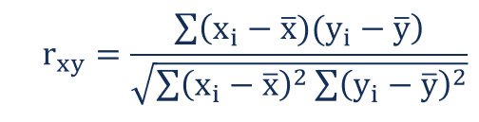

Image 10- correlation coefficient
Reference: https://cdn.corporatefinanceinstitute.com/assets/correlation1.png
Where:
- r_{xy} – the correlation coefficient of the linear relationship between the variables x and y
- x_{i} – the values of the x-variable in a sample
- x̅ – the mean of the values of the x-variable
- y_{i} – the values of the y-variable in a sample
- ȳ – the mean of the values of the y-variable

Example:
John is an investor. His portfolio primarily tracks the performance of the S&P 500 and John wants to add the stock of Apple Inc. Before adding Apple to his portfolio, he wants to assess the correlation between the stock and the S&P 500 to ensure that adding the stock won’t increase the systematic risk of his portfolio.
To find the coefficient, John gathers the following prices for the last five years (Step 1):

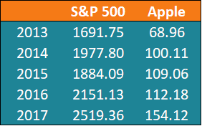

Using the formula above, John can determine the correlation between the prices of the S&P 500
Index and Apple Inc. First, John calculates the average prices of each security for the given periods (Step 2):
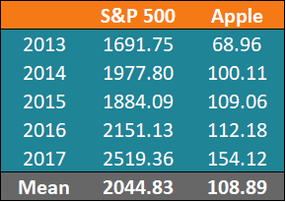

After the calculation of the average prices, we can find the other values. A summary of the
calculations are given in the table below:

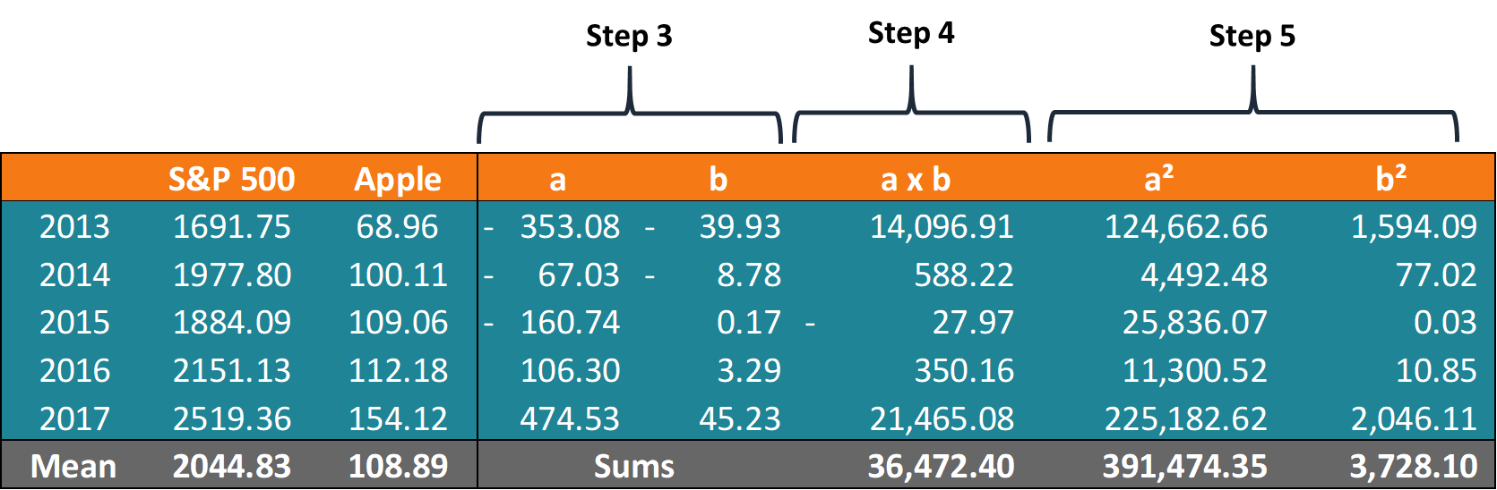

Using the obtained numbers, John can calculate the coefficient:

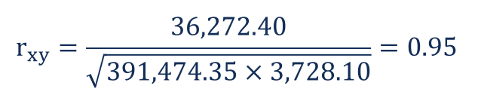

The coefficient indicates that the prices of the S&P 500 and Apple Inc. have a high positive correlation. This means that their respective prices tend to move in the same direction. Therefore, adding Apple to his portfolio would, in fact, increase the level of systematic risk.

Metrics
Regression models are another family of machine learning and statistical models, which are used to predict a continuous target values³. They have a wide range of applications, from house price prediction, E-commerce pricing systems, weather forecasting, stock market prediction, to image super resolution, feature learning via auto-encoders, and image compression. Models such as linear regression, random forest, XGboost, convolutional neural network, recurrent neural network are some of the most popular regression models. Metrics used to evaluate these models should be able to work on a set of continuous values (with infinite cardinality), and are therefore slightly different from classification metrics. A function that calculates loss for 1 data point is called the loss function.
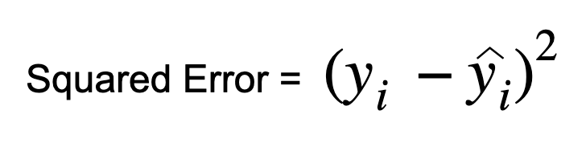
- Mean Squared Error (MSE) / Mean Squared Deviation (MSD)
The Mean Squared Error measures the average of the errors squared. It basically calculates the difference between the estimated and the actual value, squares these results and then computes their average. Because the errors are squared, MSE can only assume non-negative values. Due to the intrinsic randomness and noise associated with most processes, MSE is usually positive and not zero.
Let’s assume we have a regression model which predicts the price of houses in Seattle area (show them with ŷᵢ), and let’s say for each house we also have the actual price the house was sold for (denoted with yᵢ). Then the MSE can be calculated as:
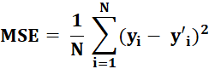
Like the variance, MSE has the same units of measurement as the square of the quantity being estimated. Similarly, to the Variance, one major disadvantage of Mean Squared Error is that it is not robust to outliers. In case a sample has a “y” and associated error which is way larger than the other samples, the square of the error will be even larger. This, paired to the fact that MSE calculates the average of errors, makes MSE prone to outliers.
- Root Mean Squared Error (RMSE) / Root Mean Squared Deviation (RMSD)
Similarly, to the Mean Squared Error, RMSE calculates the average of the squared errors across all samples but, in addition, takes the square root of the result, effectively taking the square root of MSE. By doing so, RMSE provides an error measure in the same unit as the target variable. For instance, if our target y is next year’s sales in dollars, RMSE will give the error in dollars, while MSE would be in dollars squared, which is much less interpretable.
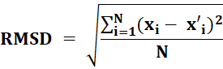
- Mean Absolute Error (MAE)
The Mean Absolute Error does not take the square of the errors. Instead, it simply calculates the absolute value of the errors and then takes the average of these values. The MAE takes the absolute value as we are not interested in the direction in which the estimated and actual target values differ (estimated > actual or vice-versa) but on the absolute distance. This also avoids errors to cancel each other out when calculating the MAE.
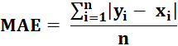
Differently from MSE, MAE does not penalize larger errors more than smaller ones, because the formula for MAE does not apply the square to errors. Another advantage is that MAE does not square the units, similarly to RMSE, making the results more interpretable.
- R Squared (R²) / Coefficient of Determination
R Squared (R²) represents the proportion of the variance for the dependent variable y that’s explained by the independent variables X. R² explains to what extent the variance of one variable explains the variance of the second variable. So, if the R² of a model is 0.75, then approximately 75% of the observed variation can be explained by the model’s features.
R² is calculated by taking one minus the sum of squares of residuals divided by the total sum of squares.
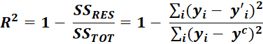
R² compares the fit of the chosen model with that of a horizontal line, which acts as a baseline. If the chosen model fits worse than a horizontal line, the R² is negative. Because of the formula of R², even though the “square” is involved, it can have a negative value without violating any rules of math. R² is negative only when the model does not follow the trend of the data and fits worse than a horizontal line.

References
- https://www.geeksforgeeks.org/machine-learning/
- https://towardsdatascience.com/performance-metrics-in-machine-learning-part-2-regression-c60608f3ef6a
- https://corporatefinanceinstitute.com/resources/knowledge/finance/correlation/
- https://www.i2tutorials.com/tag/ordinary-least-square-method-in-machine-learning/
- https://statisticsbyjim.com/glossary/ordinary-least-squares/
- https://www.potentiaco.com/what-is-machine-learning-definition-types-applications-and-examples
- https://www.investopedia.com/terms/m/mlr.asp#:~:text=Key%20Takeaways-,Multiple%20linear%20regression

